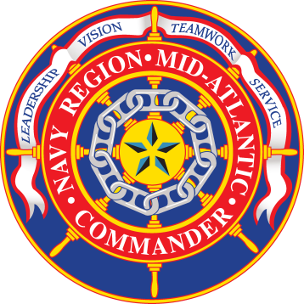

**Department of the Navy**

**Navy Region Mid-Atlantic**

**Public Affairs Office**

**1510 Gilbert St., Ste. 207**

**Norfolk, VA 23511**

**Tel: (757) 322-2853**

**Fax: (757) 445-1953**

NEWS MEDIA ADVISORY 25-05 March 27, 2025

**Arraignment held for Sailor charged in death of Sailor at Naval Weapons Station Yorktown**

**NORFOLK, Va.** – An arraignment was held on Naval Station Norfolk today for Master-at-Arms Second Class Petty Officer Jackson Bower. Bower, assigned to Naval Weapons Station Yorktown, is charged in connection with the death of Master-at-Arms Third Class Lyndon Joel Cosgriff-Flax. Cosgriff-Flax was killed during a boating incident on the York River on April 28, 2024.

Last week, the Convening Authority referred charges for Bower. He is charged with negligent homicide in the death of Cosgriff-Flax, making a false official statement, and two counts of dereliction of duty.

No General Court Martial date has been set.

###

**NOTE TO MEDIA:** For additional information on the military justice process and courtroom decorum, visit www.cnic.navy.mil/regions/cnrma/news/media/